Eightwood Aluminum Electronic Project Box Enclosure Split Body Case DIY 4.72 x 3.82 x 1.57 inch (LxWxH)
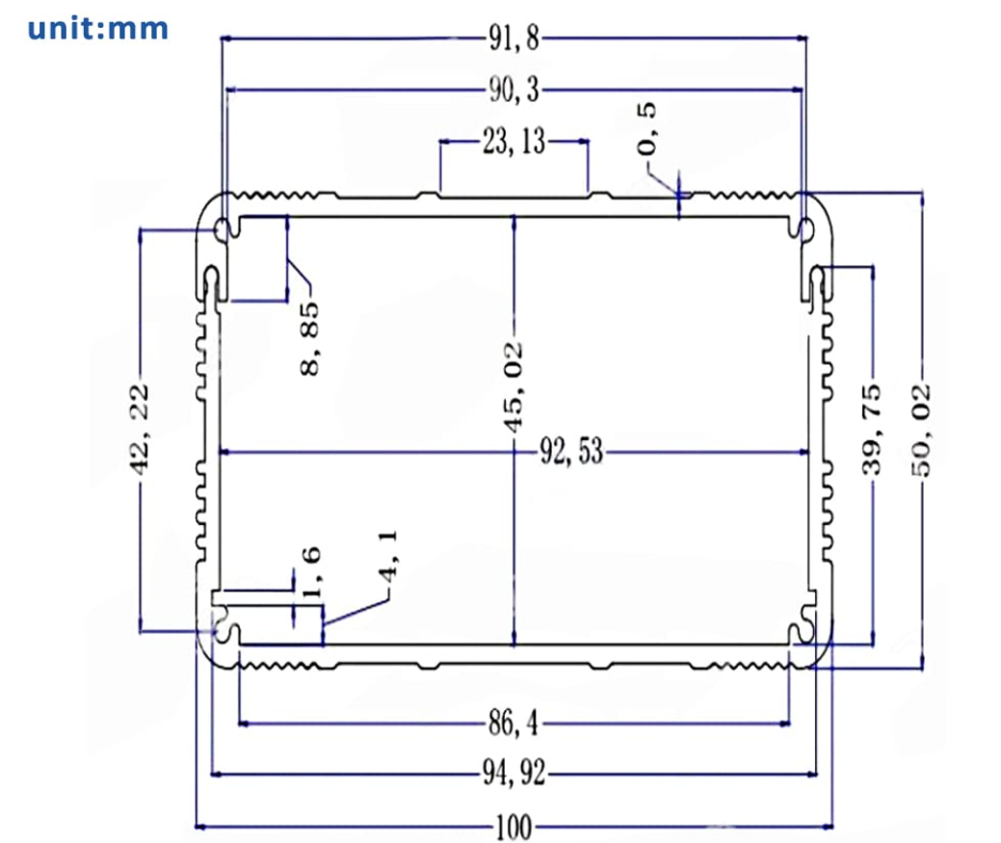

Eightwood Aluminum Enclosure Electronic Project Box Case for PCB Instrument Amplifier DIY 3.94 x3.94 x1.97 inch (LWH)
